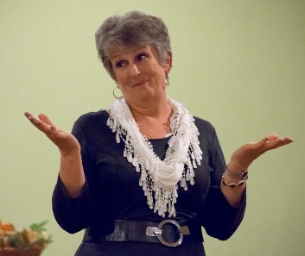

Programs:

A Heroic Journey Called Recovery
Stories that illustrate, illuminate, and celebrate recovery.

Truffles and Kerfuffles: Tales from the Kitchen
A gifted cook from "Once Upon a Time" shares tales of food, family, fun.

The Umbilical Cord Just Gets Longer
Stories about the lengths to which a mother will go to save her children.

The Back Story
Tales of children and the people who think they raise them.

Libby Beaman: Pioneer to Alaska
A one woman show based on Libby's 1879 journal.

A Ghost Named Charlie & Other Spooky Tales
Degree of scary adjusted for each audience.

Peter Pan
An interactive experience in learning to fly.

Celtic Myths, Legends and Folktales
Traditional stories from Ireland, Scotland, Britain and Wales

Beth can craft a program to suit your audience.

Beth Ohlsson
distillinghope@gmail.com
410-713-9615

